README:AAC DashBoard

GS Dashboard: A Dashboard Application for Animal Rescue

This application is a simple gui interface to communicate with and visualize data from a known database.

Motivation
The goal of this application is to have an intuitive feel and helpful visuals to easily see patterns in known data. The framework itself is easy to use, efficient, and open source to the public. The basis of this module is made using the Python language in conjunction with MongoDB and plotly dash+express.

Getting Started

Ensure you use Python 3 for this module and at least version 3.11.2. To check your Python version open a terminal and enter:

python -V

OR

python –version

Installation

MongoDb + mongosh

In order to use Mongodb and mongosh, installations are needed on the device.
Installation instructions are found at:

MongoDB → https://www.mongodb.com/docs/manual/installation/

mongosh → https://www.mongodb.com/docs/mongodb-shell/install/?operating-system=windows&windows-installation-method=msiexec

The PyMongo driver is also listed on the Mongodb site and download instructions are listed.

The CRUD_Python_Module is available on github under
https://github.com/github/USERNAME/CRUDPython.

Plotly dash→ https://docs.plotly.com/
Pandas→ https://pandas.pydata.org/

CRUD_Python_Module

Usage

This module is used for basic CRUD operations using the Python language. This module utilizes the PyMongo driver to use Python to call the MongoDB database commands. This driver was chosen because it is developed and maintained by MongoDB, making it the safest choice, in terms of usage and documentation.

DOCUMENT CREATION
In order to add a document,
- Initialize the AnimalShelter object to create a MongoDB client object that can connect to the database. Connecting to the database requires a username and password created via using mongosh. (Creating a user is shown in later sections.)
Code:
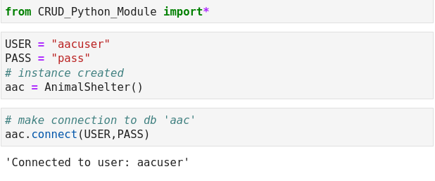
- Use the create function from the database object using a python dictionary object as a parameter for data. A new ObjectID is already instantiated inside the create function. A value of “True” or “False” will return from the function signifying creation status.

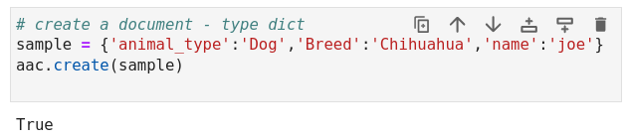

FETCHING DOCUMENTS

Fetching the documents in this module uses the find(param) method to fetch documents via query parameters. The parameter is a dictionary object with the field name as the key.

The function returns all documents in a list format matching the query, if none match, then an empty list is returned.

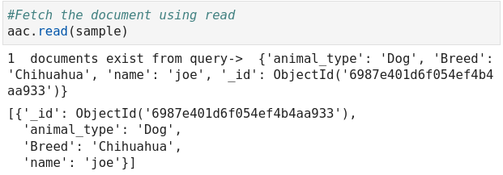

UPDATING DOCUMENTS

Updating a document uses the update(q,a) function which takes 2 parameters, a query filter and an action. Both parameters are dictionary objects and follow suitable forms for MongoDB functions.

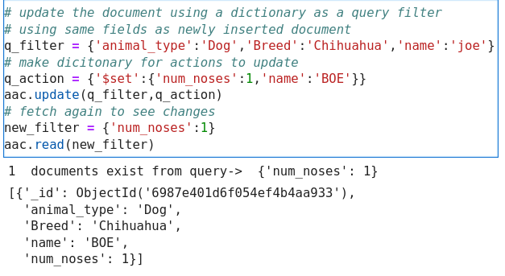

DELETING DOCUMENTS

Deleting documents uses the delete(q,MODE) function to delete a document/s based on a query filter. The filter is a dictionary object and the MODE is a boolean parameter “many” which is initially set to “False”.

If MODE is “True” then the mongodb function “delete_many()” is used and if “False” then “delete_one()” is used.

The function returns a result showing the number of documents deleted.

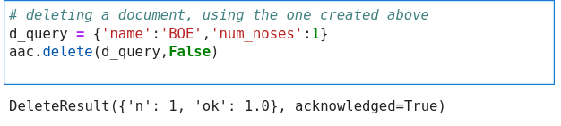

GRAVIOSO Dashboard
Describe the required functionality of the project. Include the screenshots or screencast taken while testing and deploying your dashboard (Step 6) as proof that you have achieved the required functionality.
The dashboard is developed using the python based Plotly Dash framework. This is a pure Python web application framework, making it easy to work with CRUD Module and Mongodb. The dashboard is a fully functional visualizer of large data. Some main components are:

- a data table
- a map
- a scatter plot
The data table is the main component of the application.
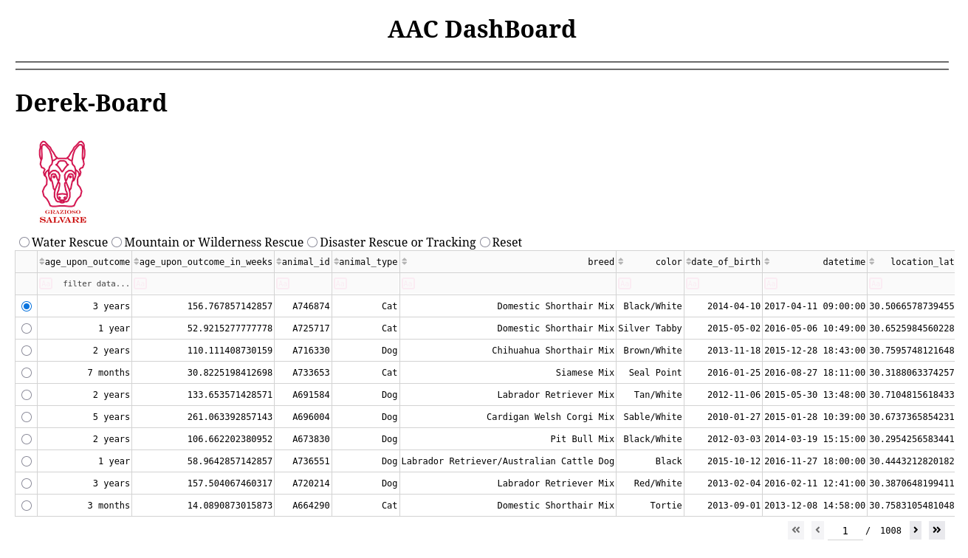
(Default View)

You can:
-select a row by clicking the radio button on the left most column, which will update the map at the bottom left, showing the location of the selection.

-filter out the data by typing in the fields at the table headers

-sort the data by clicking the arrows in the headers which go in ascending or descending order.
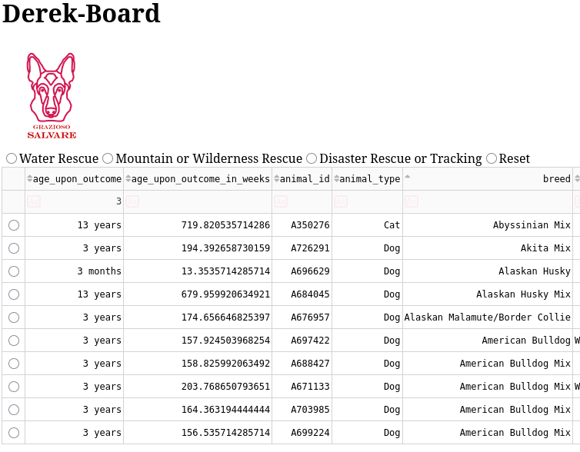
(Filtering in the age_upon_outcome column and sorting in the breed column)

The other 2 components are map objects, both plotly.express figures. The map on the left shows the exact location of a selected animal from the table. The map on the right displays all animals available in the table as a scatter plot. Points are latitude and longitude.

Selecting one of the radio buttons at the top of the data table will filter the animals to the specified types required by Gravioso.

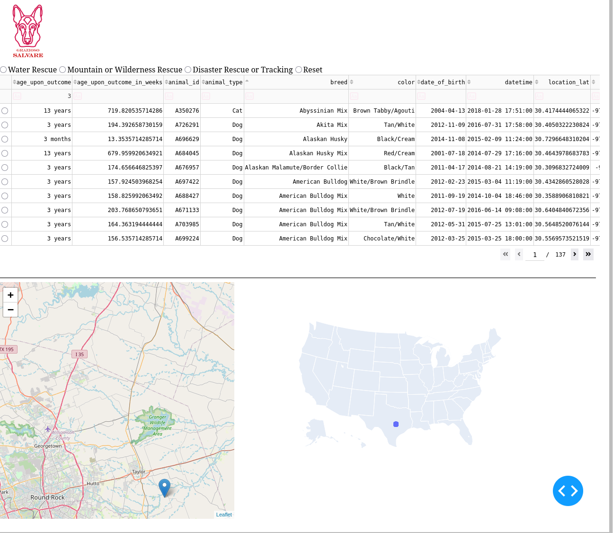
(Default maps, scatter must increase zoom to better view density)

If there are no results, charts will be removed and the data table will be blank.
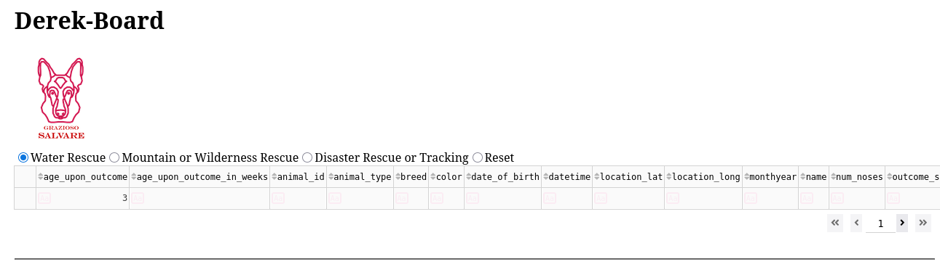
(With a filter of 3 and set to water rescue, there are no results, maps will be removed.)

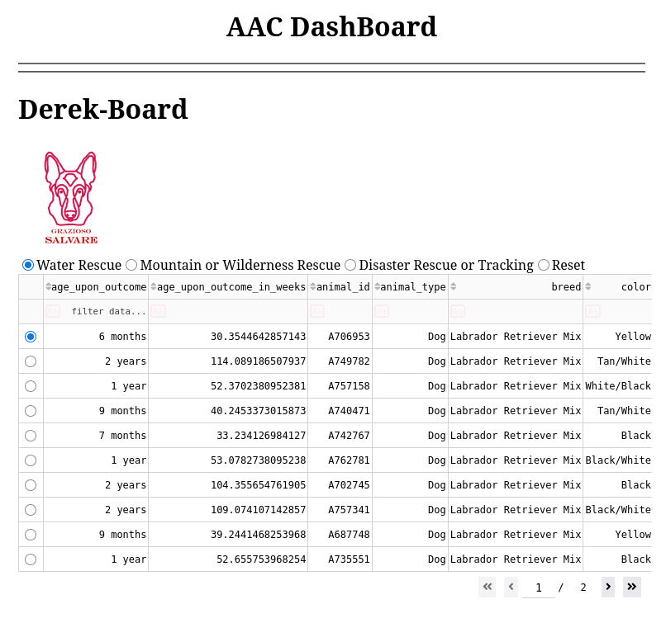
(Selection of the Water Rescue filter)
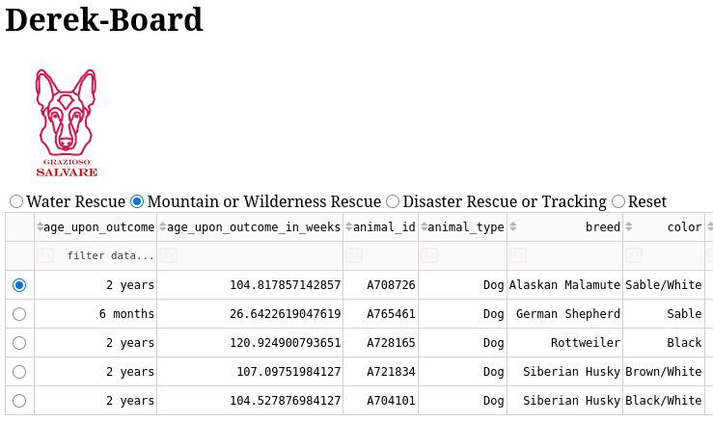
(Selection of the Mountain Rescue filter)
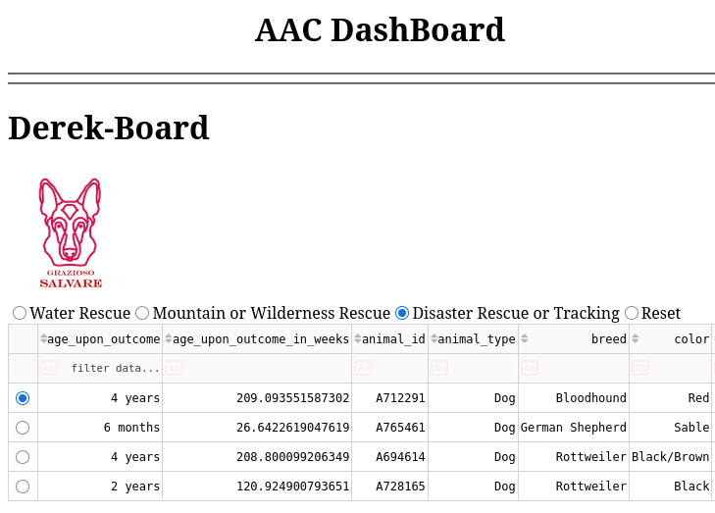
(Disaster selected filtering)
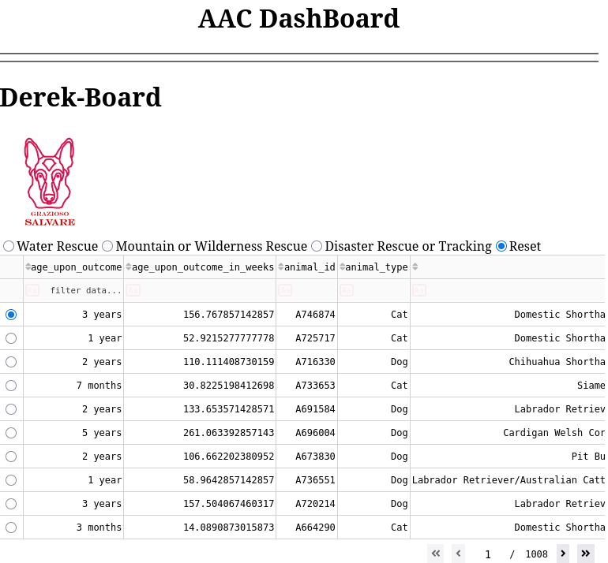
(Reset filter clicked, returns entire collection)

Clicking the last radio button “Reset” resets the filters and retrieves the entire collection.

These figures are made through a combination of frameworks and modules. Starting from the bare bones, Mongodb is used to hold all of the data. The CRUD module created in Python acts as the mediator between the database and the dashboard. The Pandas framework is used to create a more friendly container for the dashboard. Finally, Dash is used as the UI because it is also in Python and uses a simple schema to create the web application.

All of these components are open source as well or have community versions, making them easy to modify as needed and contain plenty of resources.

Links for these frameworks are listed below and in the installation section.

Code:

To get the application working using dash, the main components of it are setting up the layout and making the callbacks to those components.
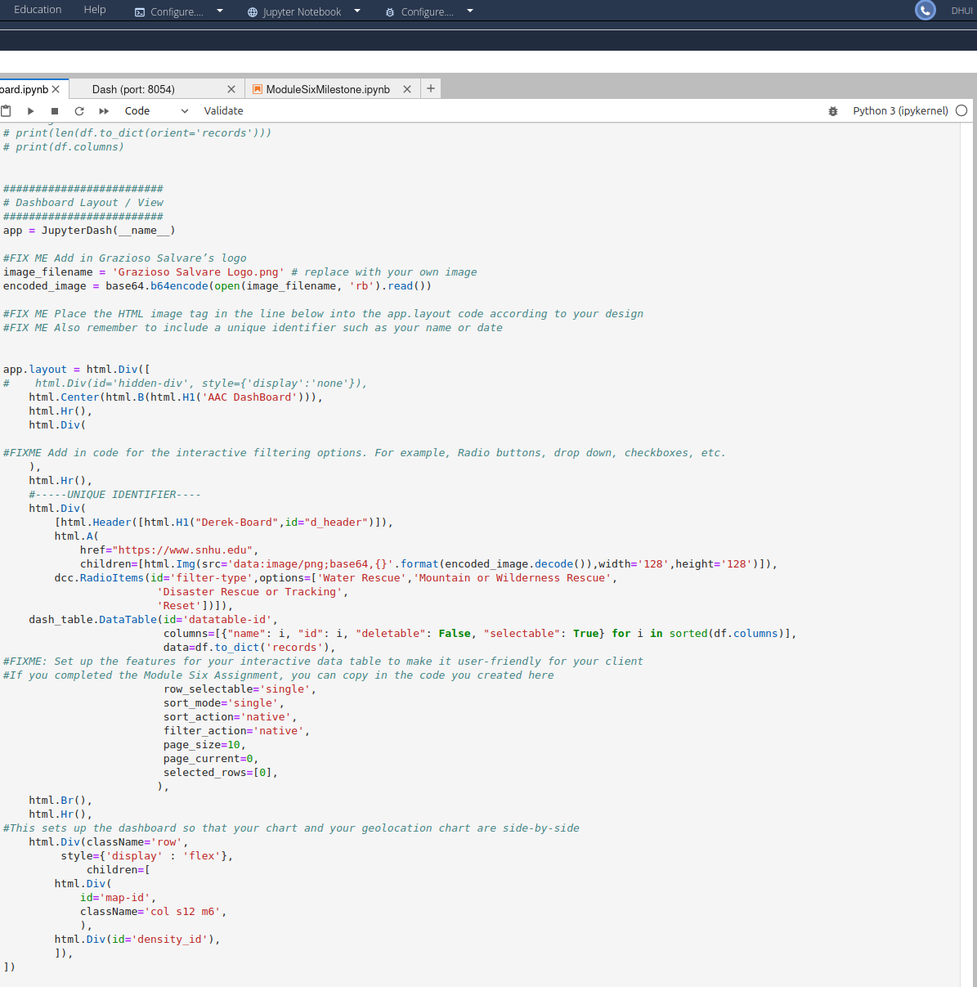
You have a central layout on the page where you list the different containers or “divs”, which in turn contain their own components. This is where you create your visuals. A difficult aspect of this at first is the readability of the code. You have to keep in mind of maintaining your ids for the components and making sure the correct properties are used.

The second component of the application are the callbacks. The callbacks are decorated functions that run whenever there is a change to the ui.
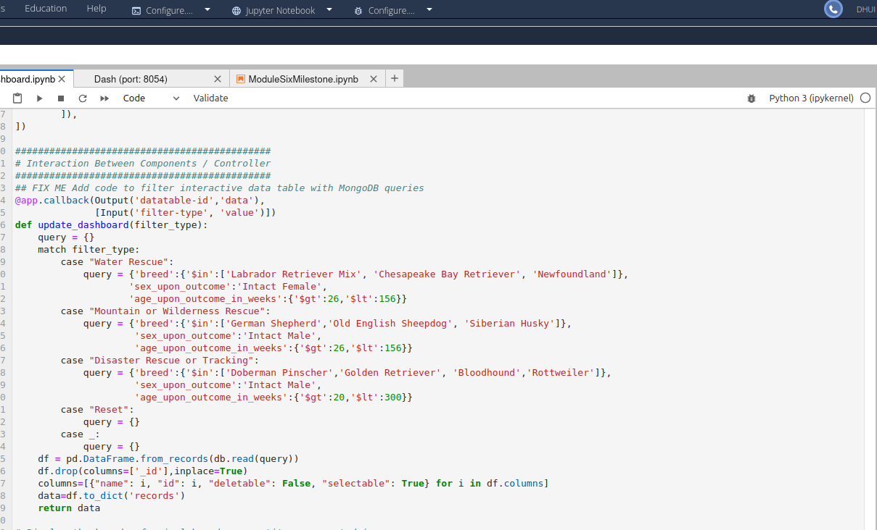
Each callback function takes an output and input, which can be multiples of each. The main challenge here is order. In a callback, the way you list the inputs and outputs must match the way they are set in the layout. This is because these functions run whenever there is a change in a ui component and checks all inputs everytime. It will match the change based on the order and send the output to the ui component.

Many of these challenges took much sifting through documentation and trial and error. The simplest part was making the right queries for the filtering system. The plotly documentation was large, but often difficult to read through. If the documentation did not suffice, then I sifted through the community posts or StackOverflow. Stack acted as a good resource because a problem I encounter is almost always one someone else has encountered as well.

